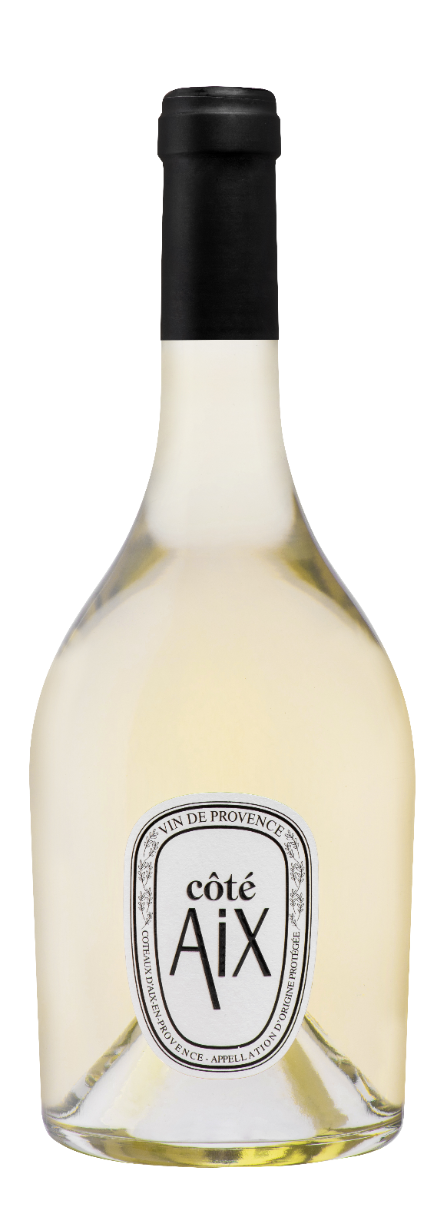
Côté AIX

AOP COTEAUX D'AIX EN PROVENCE

Rosé
75 cl – EAN : 3455098400312
12, 5 %. Vol
ORGANIC

As persistent with its citrus aromas as it is fresh with its minerality, It enchants us with its Provençal style. Coté Aix is a very inviting wine for a festive and convivial meal. Fresh and mineral, it seduces with its brilliance and fruity notes.

TERROIR
Facing south, the vines flourish on a rocky clay-limestone soil, which helps retain freshness and moisture.


cÉpages
Rolle


Accords mets & vins
A roasted coral trout fillet with herbs, a tartine of fresh goat cheese, honey and rocket or a raspberry tart.

